Nodejs Application Automation

Step 1:
Launch 2 instance Jenkins and Nodejs app
- Login to Jenkins server
Install java, nodejs, npm and Jenkins
#sudo -i
# apt update -y
#apt install fontconfig openjdk-21-jre
#java -version
# wget -O /etc/apt/keyrings/jenkins-keyring.asc \
https://pkg.jenkins.io/debian-stable/jenkins.io-2023.key

# echo "deb [signed-by=/etc/apt/keyrings/jenkins-keyring.asc]" \
https://pkg.jenkins.io/debian-stable binary/ | sudo tee \
/etc/apt/sources.list.d/jenkins.list > /dev/null

# apt update -y
# apt install Jenkins -y
#apt install -y nodejs npm
Copy public url and login to Jenkins

Step 2:
Login to Nodejs app
#sudo apt update -y
#sudo apt install -y nodejs npm
# sudo npm install -g pm2

Go to Jenkins page
- Configure credentials
Jenkins Manage Jenkins Credentials Add Credentails Username with secret
Add username: ubuntu
Hostname: Nodejs IP
Key: add key which you downloaded while launching an nodejs instance

2
Go to Manage Jenkins tools
Search for nodejs
Name: NODEJS
Select install automatically

Search for jdk
Add name: JAVA_HOME
Enter path: /usr/lib/jvm/java-21-openjdk-amd64/
Create a simple nodejs project in Github
Create Repositories
nodejs-app/
├── package.json
├── index.js
| - Jenkinsfile
Package.json
{
"name": "simple-node-app",
"version": "1.0.0",
"main": "index.js",
"scripts": {
"start": "node index.js",
"build": "echo Build completed"
},
"dependencies": {
"express": "^4.19.2"
}
}

Index.js
const express = require('express');
const app = express();

app.get('/', (req, res) => {
res.send('Node.js app deployed using Jenkins Pipeline');
});

app.listen(3000, () => {
console.log('App running on port 3000');
});

Add Jenkinsfile
pipeline {
agent any

tools {
nodejs 'NODEJS'
jdk 'JAVA_HOME'
}

environment {
APP_DIR = "/opt/nodejs-app"
SERVER = "172.31.65.249"
}

stages {

stage('Checkout Code') {
steps {
git branch: 'main', url: 'https://github.com/Tech-devops18/nodejs-app.git'
}
}

stage('Verify package.json') {
steps {
sh '''
echo "Checking for package.json..."

if [ -f package.json ]; then
echo "package.json file is available"
else
echo "package.json not found"
exit 1
fi

echo "Validating package.json syntax..."
node -e "JSON.parse(require('fs').readFileSync('package.json', 'utf8'))"

echo "package.json syntax is valid"
'''
}
}

stage('Install Dependencies') {
steps {
sh 'npm install'
}
}

stage('Build Application') {
steps {
sh 'npm run build'
}
}

stage('Deploy to Node Server') {
steps {
sshagent(credentials: ['nodejs']) {
sh """
ssh -o StrictHostKeyChecking=no ubuntu@${SERVER} 'sudo mkdir -p ${APP_DIR} && sudo chown -R ubuntu ${APP_DIR}'
rsync -avz --delete . ubuntu@${SERVER}:${APP_DIR}
ssh -o StrictHostKeyChecking=no ubuntu@${SERVER} '
cd ${APP_DIR} &&
sudo npm install &&
pm2 restart app || pm2 start index.js --name app
'
"""
}
}
}
}

post {
success {
echo "Deployment completed successfully"
}
}
}

Step 5
Enable Security Group
Jenkins 8080
NodejsApp 3000

Step 6:

In Jenkins
Install Plugin
Manage Jenkins Plugin Available plugin
Select
Nodejs
Github authentication / Github Integration
Ssh releated plugins
Ssh agent
Ssh pipeline
Pipeline stage

Now create project:
New Item Name project Select project type as pipeline
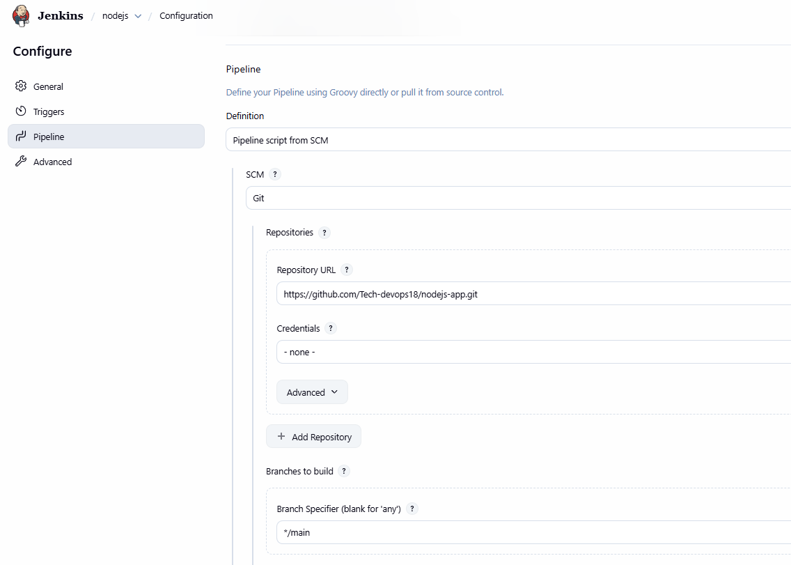

BUILD NOW

